**Assignment 5**

**COS 702 Fall 2017**

The following amoeba-like domain is bounded by

$$∂Ω=\left\{\left(rcosθ,rsinθ\right):r=e^{sinθ}\left(\sin^{2}2θ\right)+e^{cosθ}\left(\cos^{2}2θ\right)\right\}$$

Which is shown in Figure 1. Use various boundary points to reconstruct the curve and then approximate the area of the amoeba-like using Halton points.

Note: try to use different number of boundary to reconstruct the domain and then use different number of Halton points to estimate the area of amoeba-like domain.

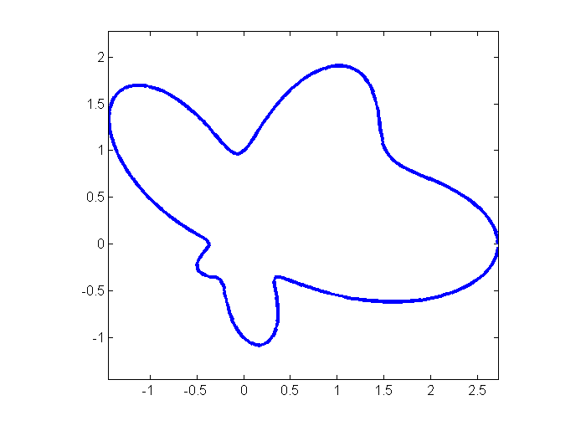

Figure 1: Amoeba-like domain.